**NATIONAL UNIVERSITY OF COMPUTER AND EMERGING SCIENCES**



**ASSIGNMENT REPORT**

**SikuliX – Automation Testing Tool**

|  |  |
| --- | --- |
| **Team Members** | 1. Faaiz Kadiwal (21K-3830) 2. Ammar Asdaque (21K-3923) 3. Anser Tayyab (21K-3909) |
| **Course Instructor** | Miss Syeda Rubab Jaffar |
| **Submission Date** | 30-October-2023 |

***Table of Contents***

|  |  |  |  |
| --- | --- | --- | --- |
| ***1.*** | ***INTRODUCTION................................................................................................................................................*** | | |
|  | *1.1.* |  | *About SikuliX..........................................................................................................................................* |
|  | *1.2.* |  | *When to use SikuliX .....................................................................................................................**..........* |
|  | *1.3.* |  | *Pros and Cons of SikuliX.......................................................................................................................* |
|  |  |  |  |
| ***2.*** | ***INSTALLATION.................................................................................................................................................*** | | |
|  | *2.1.* |  | *How to install on windows.....................................................................................................................* |
|  |  |  |  |
| ***3.*** | ***APPLICATION IN PROJECT........................................................................................................................******..*** | | |
|  | *3.1.* |  | *About Project…......................................................................................................................................* |
|  | .*3.2.* |  | *Selection Criteria...................................................................................................................................* |
|  | *3.3.* |  | *How it will be applied and integrated....................................................................................................* |
|  | *3.4.* |  | *Testing Workflows...................................................................................................................................* |
|  | *3.5.* |  | *Challenges and Mitigation......................................................................................................................* |
|  |  |  |  |
| ***4.*** | ***WORKING...........................................................................................................................................................*** | | |
| *4.1.* | | *Execution of test cases................................................................................................................................* | |
| *4.2.* | | *Conclusion.................................................................................................................................................* | |

**FOR FURTHER QUERIES CONTACT OUR TEAM,**

[**K213830@nu.edu.pk**](mailto:K213830@nu.edu.pk)

[**K213923@nu.edu.pk**](mailto:K213923@nu.edu.pk)

[**K213909@nu.edu.pk**](mailto:K213909@nu.edu.pk)

1. **INTRODUCTION: -**

*The introduction section provides a high-level overview of SikuliX, its application in the project, and the associated pros and cons.*

* **ABOUT SIKULIX: -**

*SikuliX is a powerful automation testing tool that is widely used to automate repetitive tasks and validate software applications, especially those with graphical user interfaces (GUIs). It stands out due to its image-based automation approach, allowing testers to interact with the interface by matching and manipulating elements using screenshots and images.*

* **WHEN TO USE SIKULIX: -**

*SikuliX is most effective when dealing with applications that have GUI-intensive user interfaces, making it ideal for testing projects with graphical components. It excels when the project requires precise validation of visual elements and interactions. In the case of the Fast University Food Ordering Application, which relies on JavaSwings and JavaFX, SikuliX's image-based automation approach is particularly relevant.*

* **PROS AND CONS OF SIKULIX: -**

**PROS**

* ***Image-Based Automation:*** *SikuliX boasts an impressive capability to perform image-based automation. This means it can accurately recognize and interact with graphical elements within applications. When dealing with GUI-intensive applications like the Fast University Food Ordering Application, this feature becomes invaluable. SikuliX captures screenshots of elements or regions of the screen and uses these images as reference points to interact with the user interface. This approach ensures that even if the application's UI changes, SikuliX can adapt and continue to perform reliably.*
* ***Compatibility with Java:*** *SikuliX's compatibility with Java, made possible through Jython (Python integrated with Java), aligns it perfectly with projects built on a Java-based technology stack. Given that the Fast University Food Ordering Application uses JavaSwings and JavaFX for its graphical interface, SikuliX seamlessly integrates with the application's technology stack, allowing for the testing of the entire system, including the backend and frontend components.*
* ***Cross-Platform Compatibility:*** *SikuliX's ability to work across multiple operating systems, including Windows, macOS, and Linux, ensures consistent testing across diverse platforms. This cross-platform compatibility is essential, as the Fast University Food Ordering Application should provide a consistent and reliable experience to users regardless of the operating system they are using. SikuliX ensures that the testing process can be carried out uniformly across various platforms.*
* ***Customizability:*** *SikuliX offers a high degree of customizability, allowing users to create their own functions and scripts to handle unique interactions within the application. In the context of the Fast University Food Ordering Application, this feature is particularly advantageous, as the application may have specific, customized user interactions or workflows. SikuliX's customizability empowers your team to design and implement automation solutions tailored to these unique aspects, optimizing testing efficiency.*
* ***Active Community Support:*** *SikuliX benefits from an active community of users and developers who are eager to share knowledge and provide solutions to project-specific challenges. This support network is valuable, especially when faced with questions or issues unique to the Fast University Food Ordering Application. Having a community to turn to for guidance and assistance enhances the reliability and effectiveness of the automation testing process.*

**CONS**

* ***Steeper Learning Curve:*** *SikuliX may present a steeper learning curve for users who have limited scripting or automation experience. While the tool's image-based approach simplifies the process of automation, users still need to become familiar with the software's functionalities, scripting concepts, and its unique approach to automation. For individuals who are new to automation testing, there might be an initial learning curve.*
* ***Reliance on Image Recognition:*** *SikuliX relies heavily on image recognition to identify and interact with elements on the user interface. This approach, while effective, can be sensitive to changes in the application's user interface. If the UI undergoes significant alterations, SikuliX may require corresponding updates to its automation scripts to adapt to the changes. This sensitivity to UI changes is a factor to consider when selecting SikuliX as the automation tool for a project.*

1. **INSTALLATION: -**

*This section covers the installation process of SikuliX on Windows.*

* **HOW TO INSTALL ON WINDOWS: -**

*To install SikuliX on Windows:*

* + - * 1. *Visit the official SikuliX website (https://sikulix.com/) to download the Windows version.*

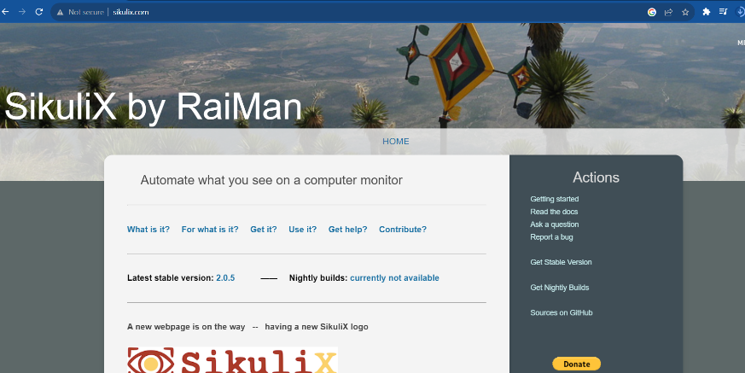

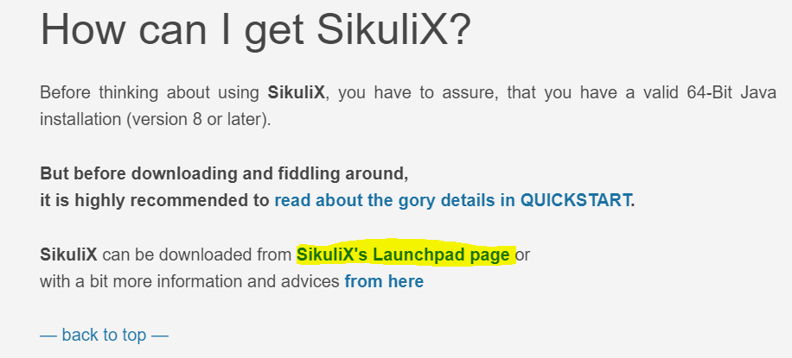

* + - * 1. *Double-click the downloaded installer to start the installation process.*

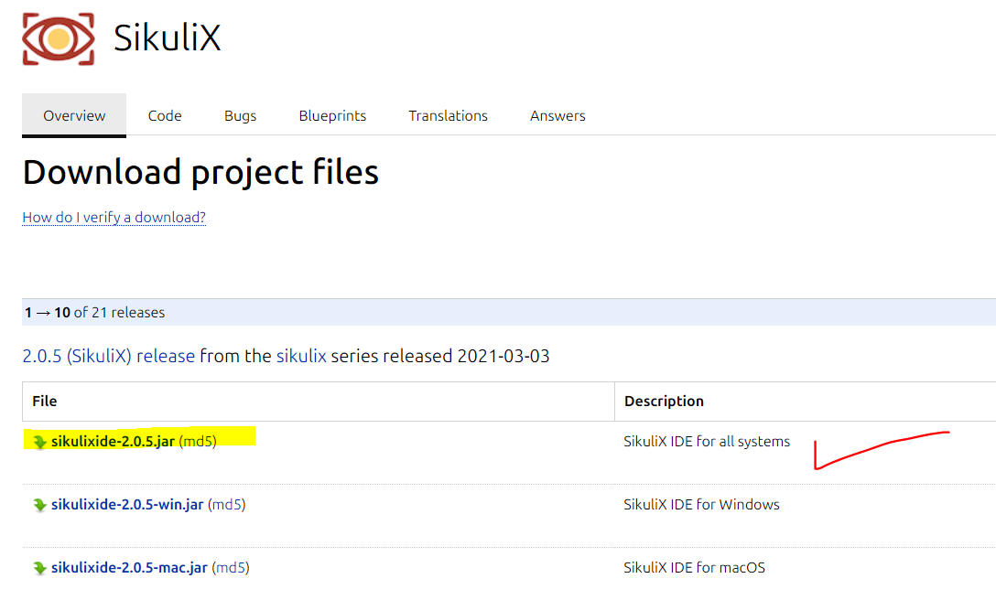

* + - * 1. *Follow the on-screen instructions to complete the installation.*

**

* + - * 1. *Once installed, launch SikuliX and start using it for your automation testing needs*

**

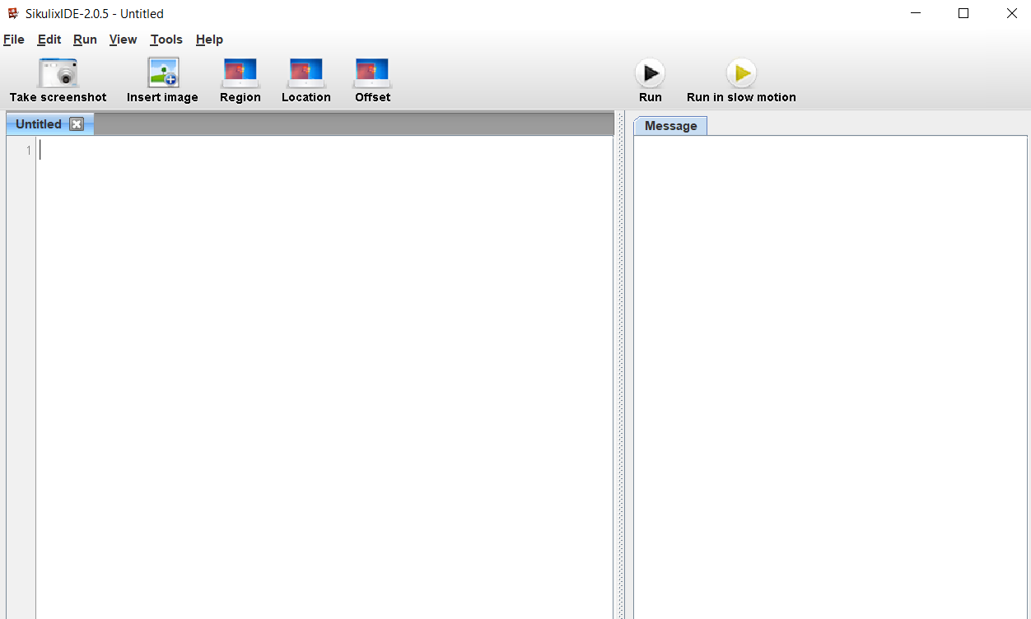

1. **APPLICATION IN PROJECT: -**

*In this section, we delve into how SikuliX is applied and integrated into the Fast University Food Ordering Application project.*

* **ABOUT PROJECT: -**

*The Fast University Food Ordering Application is a desktop application for ordering food within the university campus. It offers a user-friendly system for ordering from various on-campus venues. The choice of SikuliX for automation testing is driven by the application's GUI-intensive nature, Java-based backend, and cross-platform requirements.*

*Refer to the following quality plan for detailed info of project;*

**

* **SELECTION CRITERIA: -**

*The selection of SikuliX as the automation testing tool was based on specific criteria, including compatibility with the project's technology stack, ease of use, suitability for GUI-intensive applications, cross-platform support, customizability, and active community support.*

* **HOW WILL IT BE APPLIED AND INTEGRATED: -**

*SikuliX will be seamlessly integrated into the project by using SikuliX IDE and SikuliX API for script creation and execution. This approach will ensure efficient testing of various aspects of the application, including user login and food ordering functionalities.*

* **TESTING WORKFLOWS: -**

*The testing workflow involves script creation, execution, verification, and reporting. SikuliX will record and report test results, including pass/fail status, log files, and screenshots, which will be used for analysis and communication with the development team.*

* **CHALLENGES AND MITIGATION: -**

*Challenges in implementing SikuliX, such as script maintenance, will be addressed through version control and meticulous documentation. The active SikuliX community will serve as a resource for addressing challenges as they arise.*

1. **WORKING: -**

* **EXECUTION OF TEST CASES: -**

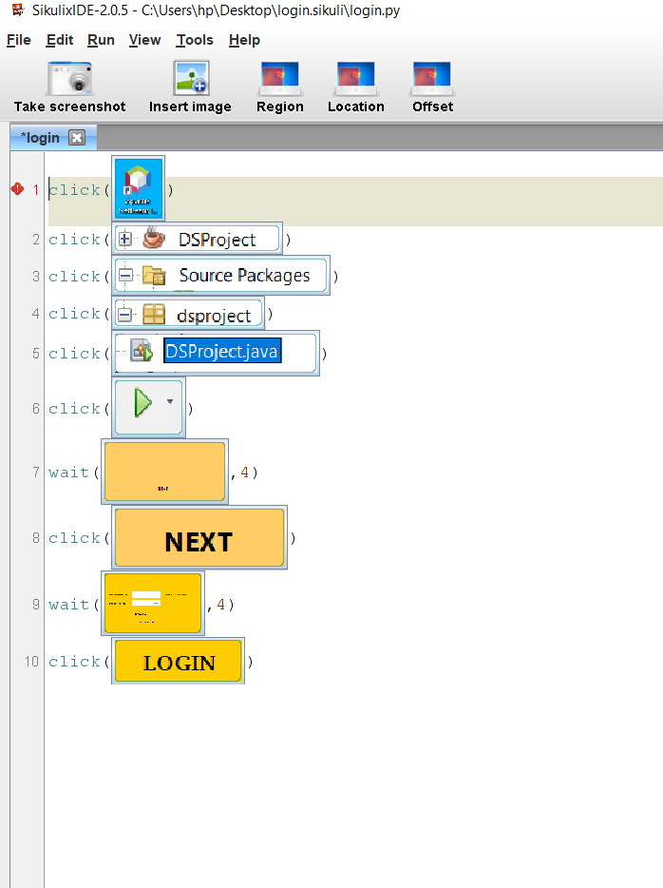

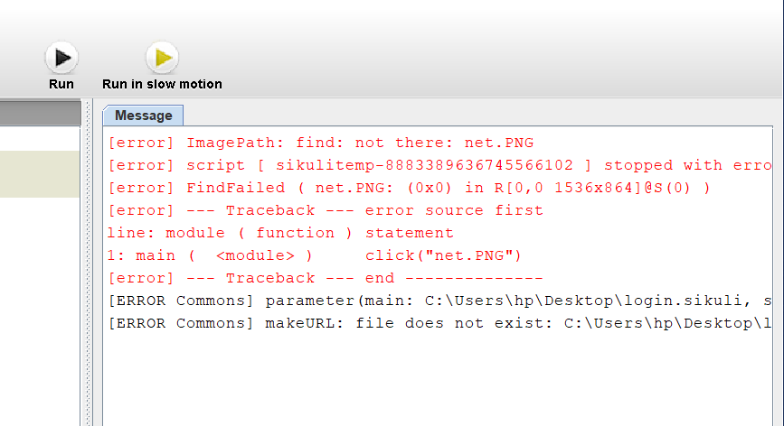

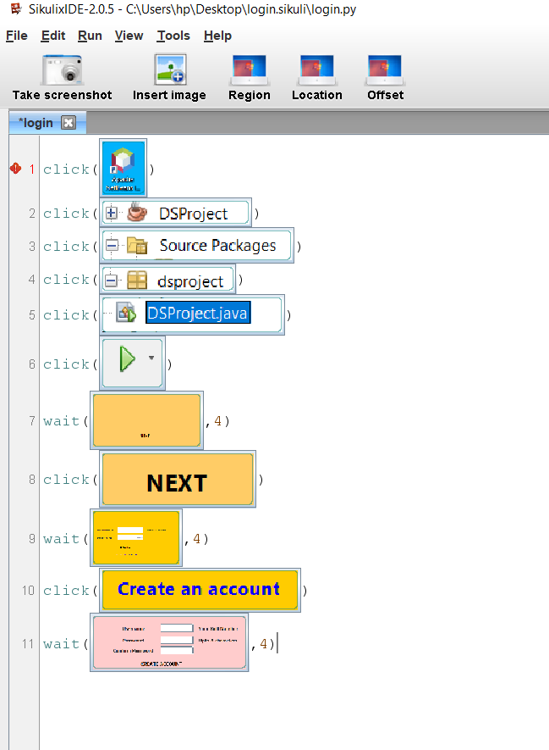

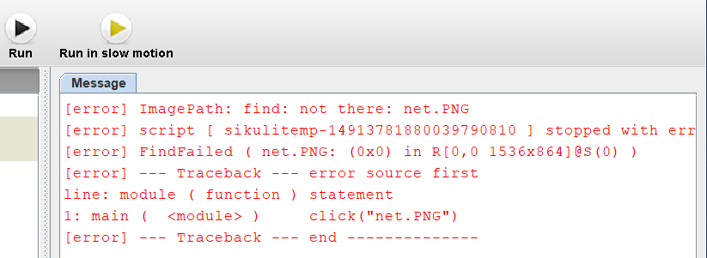

*Now as the project is not completed yet hence the following test cases has errors running because the path, pics and other required contents in script has no approved working yet, so to prove the working of SikuliX automation tool in generating and executing test cases following cases were carried;*

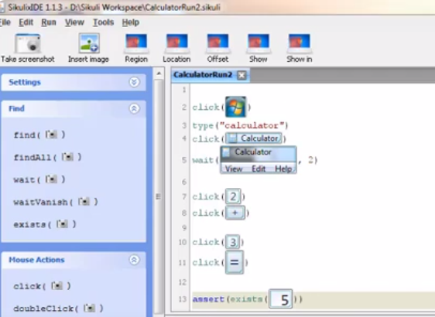

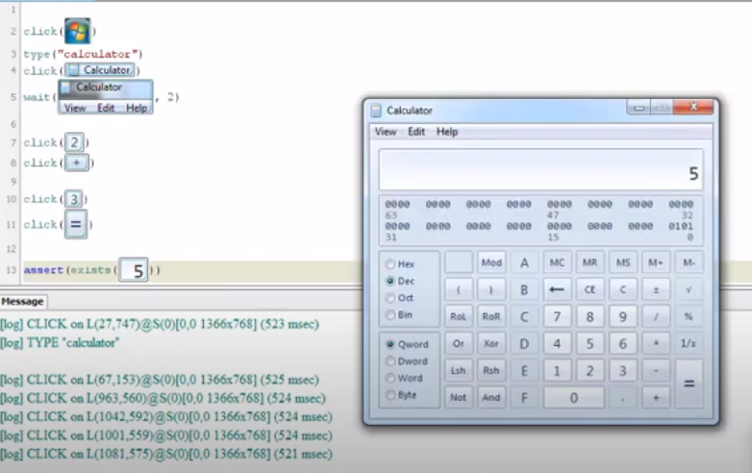

* **CONCLUSION: -**

*The integration of SikuliX into the project ensures thorough and consistent testing, contributing to the overall quality and reliability of the Fast University Food Ordering Application. Automation testing using SikuliX empowers team members to actively participate in script creation and testing, even without extensive coding experience. As the project evolves, scripts will be maintained and updated to address changes or enhancements in the application's UI and features.*

*This report provides a comprehensive overview of SikuliX, its installation process, application in the Fast University Food Ordering Application project, testing workflows, and the practical execution of test cases. It highlights how SikuliX addresses the unique requirements and challenges of the project while offering an effective automation testing solution.*

**REFERENCES: -**

[*http://sikulix.com/*](http://sikulix.com/)

[*https://launchpad.net/sikuli/+download*](https://launchpad.net/sikuli/+download)

[*https://sikulix.github.io/docs*](https://sikulix.github.io/docs)